**CLOCK AND REGISTER OPERATION TABLE**

ADD / Addition Operation

This is an instruction that performs the ADD logic operation on bits in AC and the memory data at the effective address.

T0: AR ← PC

T1: IR ← M[AR], PC ← PC+1

T2 : I ← IR[15] , Decode D0, D1, D2, D3…..D7 ← IR[14 - 12] , AR ← IR[11-0]

D7’IT3: AR ← M[AR]

D1T4: DR ← M[AR]

D1T5: AC← AC + DR, E ← Cout, SC← 0

Click on the simulate and then click on the logging in Logisim for entering into this page to create the Table.

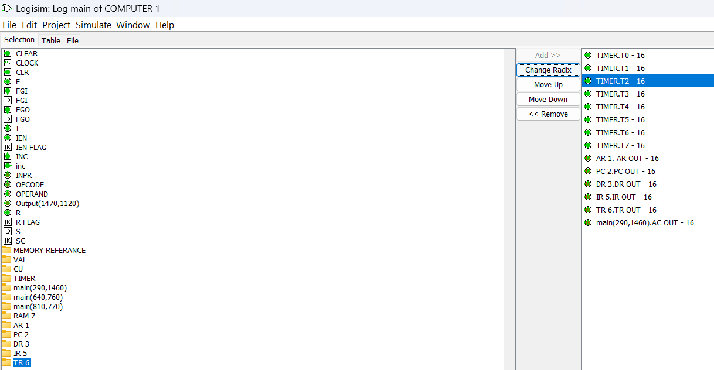

OPERATION: We have given the instruction for adding two number and that number is 3 and 5.

